To be added under country examples

Planning the strategic prioritization exercise: Country examples
Box 1: Mozambique
Key points:
- Budget data on commodities was gathered in advance of the meeting.
- The TIER tool intervention list was adapted to align with national HIV guidelines.
- All stakeholders met in a single group rather than splitting into prevention, testing and treatment sub-groups.
Summary:
- Mozambique’s HIV programme is 95% externally funded.
- Stakeholders viewed the prioritization exercise as iterative and expect to repeat it as more funding information becomes available.
- The exercise excluded human resource and systems costs.
- The Ministry of Health collected consumption and budget allocation data for medicines and diagnostics prior to the workshop, and participants viewed this information as essential for informed decision making.
- Before the meeting, the Ministry determined budget distribution based on the 2022 National AIDS Spending Assessment: 50% for care and treatment, 20% for testing, and 17% for HIV prevention.
- The group reviewed WHO recommendations within the TIER tool and compared them against national policies, then adapted the TIER tool to reflect the current suite of interventions.
- Participants modelled three funding scenarios using the adapted tool: 0%, 30%, and 70% of current external funding levels.
- The Ministry held a one-day internal technical working group (TWG) meeting to review the draft prioritization.
- A two-day multi-stakeholder workshop brought together civil society, donors, and implementing partners from across prevention, testing, and care and treatment.
- Experts from all programme areas jointly reviewed each section of the TIER tool. The exercise was intentionally completed together so every group understood how de-prioritization in one part of the cascade affects others.

Table x: Summary of prioritization outcomes across the cascade
Treatment | Testing | Prevention
- ART maintenance remained a priority. Under the 0% scenario, initiation would focus on children, pregnant/breastfeeding women, and people with advanced HIV disease (AHD).  - Out-of-facility activities, including DSD models, were deprioritized.  - The full AHD package was deprioritized due to high cost.  - Viral load testing and tracking/tracing were excluded or reduced under 0% and 30% scenarios. | - Community-based testing was de-prioritized.  - HIV testing integrated into family planning services stopped. | - Most prevention interventions were deprioritized in reduced-funding scenarios.  - Post-natal prophylaxis for infants and facility-based PrEP remained prioirties.  - PrEP for pregnant and breastfeeding women remained in the at 50% scenario, driven by PEPFARs inclusion of this in their waiver.  - All other PreP services, harm reduction and community condom distribution was deprioritized.

BOX 2: Ghana
Key points
- Decision making was guided by existing cost effectiveness analyses of specific activities.
- Commodities were considered essential and protected these from cuts.
- Projected budget savings came from adjusted systems-level activities such as supervision, DSD monitoring and training.
- Ghana is considering reducing clinical visit frequency to annual for those who are established on treatment.

Summary:
- PEPFAR supports three of Ghana’s 16 regions; the Global Fund remains the principal external funder.
- Ghana initially reprogrammed its budget through exchange-rate savings and efficiencies in existing activities.
- The Global Fund reprioritization process already identified low-impact and low-uptake interventions for de-prioritization, including individual out-of-facility and community pharmacy models. Facility-based group models remain supported.
- PATHS guidance helped to engage Global Fund sub-recipients early in the prioritization process.
- Ghana used the TIER tool as a framework and adapted it to national guidance.
- Stakeholders had commodity and activity-level budgets available to guide decisions.
- They protected prevention, testing, and treatment commodities as non-negotiables.
- They reviewed the possibility of reducing systems activities to create savings, including monitoring, supervision, and training.
- They are evaluating potential savings from moving annual clinical visits to people established on treatment.

CQUIN country prioritization outcomes using the adapted TIER tool
The HIV Coverage, Quality and Impact Network (CQUIN), led by ICAP at Columbia University, supported the 21 member countries to complete prioritization exercises. Countries were encouraged to complete an adapted TIER tool, prioritize monitoring and evaluation indicators, and share strategic planning meeting plans.
The CQUIN-adapted TIER tool considered what to maintain or drug under two donor-funding scenarios: 0% and 50%. Costing data were not available during the exercise.
A summary of outcomes from the prioritization processes of fourteen countries was presented during an August 2025 webinar (Figures 1-3). Overall, countries prioritized maintaining the current HIV treatment programmes (Figure 1). some countries prioritized out-of-facility DSD models and investments in home tracing. The most commonly deprioritized testing services included recency testing and targeted outreach (Figure 2). Frequently deprioritized prevention interventions were out-of-facility activities, needle and syringe programmes and naloxone for people who use drugs (Figure 3).

Figure 1: Prioritization Outcomes: Treatment
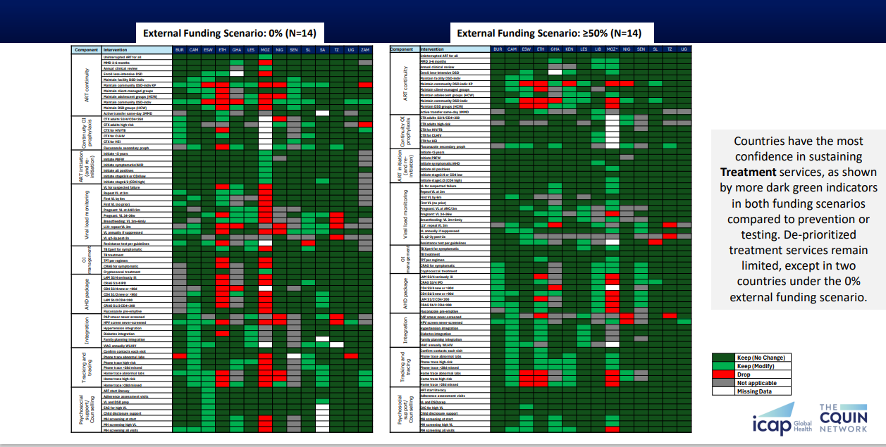
Figure 2: Prioritization Outcomes: Testing
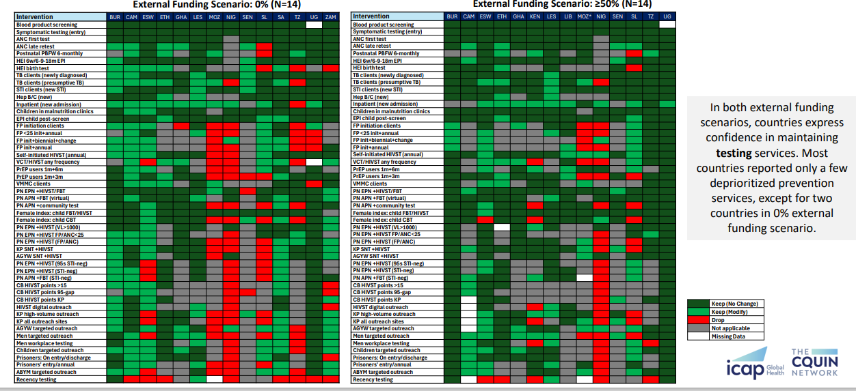

Figure 3: Prioritization Outcomes: Prevention
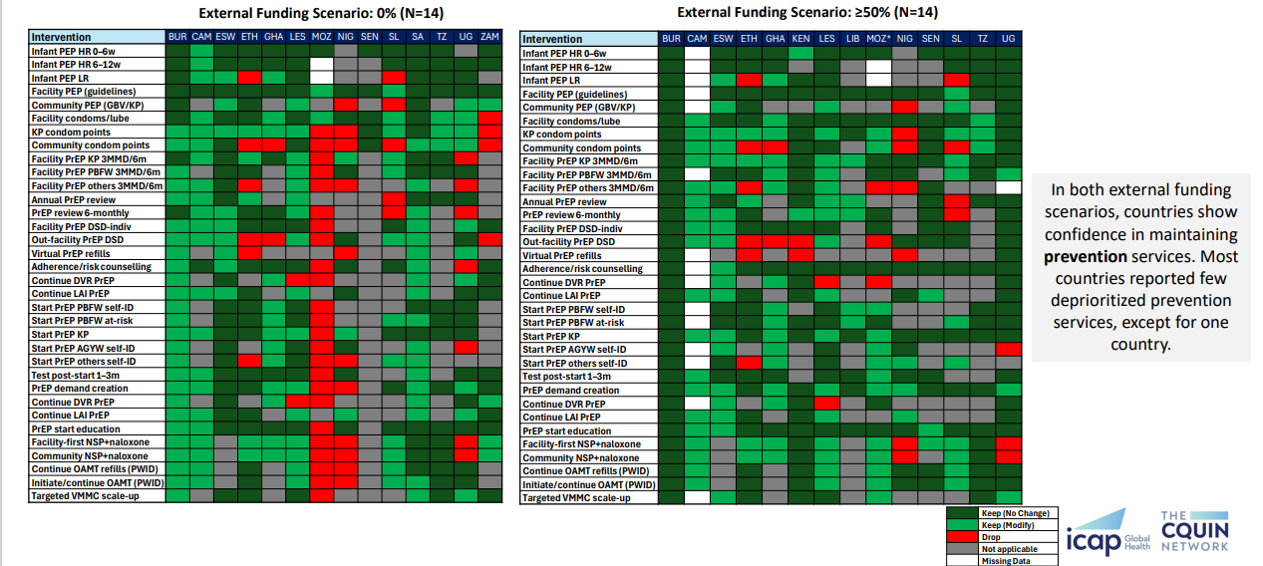

Further details of the CQUIN prioritization exercise are presented in the Strategic HIV Service Prioritisation webinar and country specific experiences from Nigeria and Kenya.
Nigeria focused major changes in testing and prevention on outreach and key population programmes (Figure 4). ART for all populations remained the primary priority. Only key population service delivery models provided opportunities for cost savings.
Figure 4: Country example: Nigeria
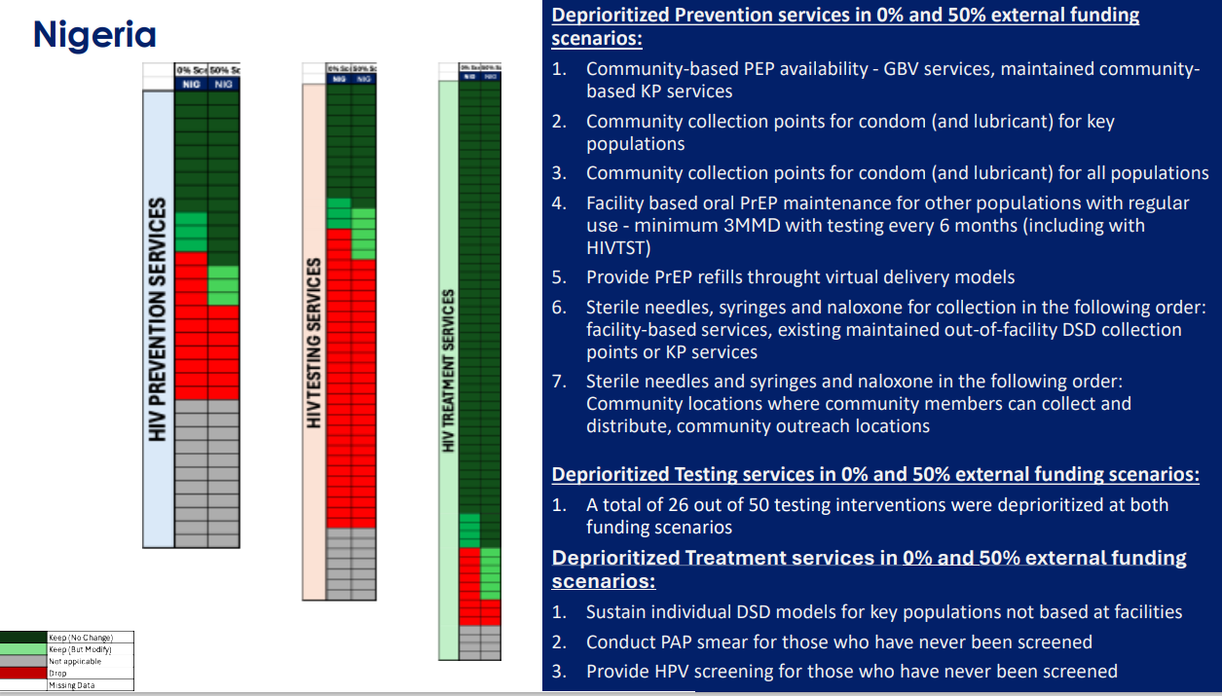

Across Kenya’s cascade, stakeholders deprioritized out-of-facility models (Figure 5). In treatment, the shift applied only to key population services. In testing, stakeholders reduced outreach testing for men alongside key population outreach points and targeted testing for adolescent boys and young men. In prevention, PrEP refills and HIVST remained available at facilities while out-of-facility PrEP models were deprioritized.
Figure 5: Country example: Kenya

